

PAKISTAN INSTITUTE OF ENGINEERING AND APPLIED SCIENCES

***Computing Fundamentals & Programming***

**FALL 2020**

Laboratory Exercise-10

Department: Physics

Name: Umar Shifaqat

Serial No. 43

Roll No. BS-20-GB-100864

Date: DECEMBER 14, 2020

**HOME TASKS**

**HOME TASK 01**

**Try to identify the various parts of the following functions and valid function calls:**

**Function-01**  (***Invalid Function***)

**float Dollar Rate(void) Function Definition**

**{**

**return85.6; Return Statement**

**}**

**Function-02 *(Valid Function)***

**int makeEven (int x) Function Definition**

**{**

**int result;**

**if(x%2==0)**

**result=x;**

**else**

**result=x+1;**

**return result; Return Statement**

**}**

**HOME TASK 02**

**(1)**

**Write a function pow() which takes two integer parameters a and n and returns nth power of a, write a program to use this function.**

**INPUT**

#include<stdio.h>

int pow(int a, int n);

void main()

{

int num=4,exp=6;

int result;

result=pow(num,exp);

printf("The %dth power of %d is %d",exp,num,result);

getchar();

getchar();

getchar();

}

int pow(int a,int n)

{

int res=1;

for(int i=0;i<n;i++)

res*=a;

return res;

}

**OUTPUT**



**(2)**

**Write a function that returns the greater of the two numbers i.e. make a function that takes two integer arguments and returns the greater of the two. Write program to use this function.**

**INPUT**

#include<stdio.h>

int greater_num(int a,int b);

void main()

{

int x=15,y=21;

int great_num;

great_num=greater_num(x,y);

printf("Of %d and %d , %d is the greater",x,y,great_num);

getchar();

}

int greater_num(int a,int b)

{

if(a>b)

return a;

else

return b;

}

**OUTPUT**

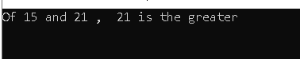

**HOME TASK 03**

**(1)**

**Write a program that calls print line function 5 times using a loop.**

**INPUT**

#include<stdio.h>

void printline();

void main()

{

int i=0;

while(i<5)

{

printline();

i++;

}

getchar();

}

void printline(void)

{

printf("\nWelcome to Boarland C++ Software");

}

**OUTPUT**

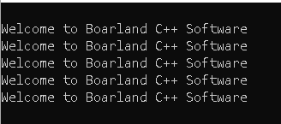

**(2)**

**Write a function void evenOdd(int), the function should print even or odd according to the number passed. Call this function in main and show the output.**

**INPUT**

#include<stdio.h>

void evenOdd(int x);

int main()

{

int a;

printf(“Enter a Number :”);

scanf("%d",&a);

evenOdd(a);

getchar();

getchar();

getchar();

}

void evenOdd(int x)

{

if (x%2==1)

printf(“%d is ODD\n”,x);

else

printf(“%d is EVEN\n”,x);

}

**OUTPUT**

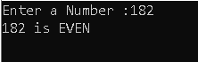

**(3)**

**Write a program that prints the status of 10 numbers as even or odd using your evenOdd() function, the numbers can be as simple as 1-10 or can be between two numbers A and B provided by the user.**

**INPUT**

#include<stdio.h>

void evenOdd(int x);

int main()

{

int i,start,end;

puts(“Enter a number for the beginning”);

scanf(“%d”,&start);

puts(“Enter a number for the end”);

scanf(“%d”,&end);

for(i=start;i<end;i++)

{

evenOdd(i);

}

getchar();

}

void evenOdd(int x)

{

if (x%2==1)

printf(“%d is ODD\n”,x);

else

printf(“%d is EVEN\n”,x);

}

**OUTPUT**

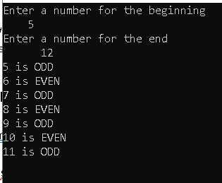

**HOME TASK 04**

**Write a program that produces a good looking output for even odd problem.**

**INPUT**

#include<stdio.h>

void printLine(void);

void evenOdd(int x);

int main()

{

int i,start,end;

puts("Enter a number for the beginning");

scanf("%d",&start);

puts("Enter a number for the end");

scanf("%d",&end);

for(i=start;i<end;i++)

{

evenOdd(i);

}

getchar();

getchar();

getchar();

}

void evenOdd(int x)

{

void printLine(void);

if (x%2==1)

printf("%d is ODD\n",x);

else

printf("%d is EVEN\n",x);

void printLine(void);

}

void printLine(void)

{

printf("\n**************************************************\n");

}

**OUTPUT**

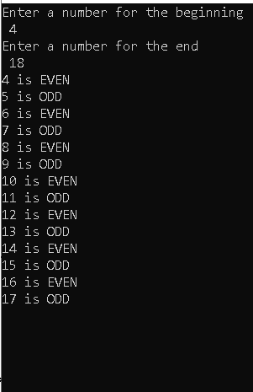

**HOME TASK 05**

**Write a program take input from user and get the largest element of an array using the function.**

**INPUT**

int max;

void largest(int x);

void main()

{

int i,n,array[100];

printf("Input the number of Elements to be stored in the array: ");

scanf("%d",&n);

printf("\nInput %d elements in the array\n",n);

for(i=0;i<n;i++)

{

printf("Element - %d: ",i+1);

scanf("%d",&array[i]);

}

max=array[0];

for(i=0;i<n;i++)

largest(array[i]);

printf("\n*********The largest element is %d**********",max);

getchar();

getchar();

getchar();

}

void largest(int x)

{

if(x>max)

max=x;

}

**OUTPUT**

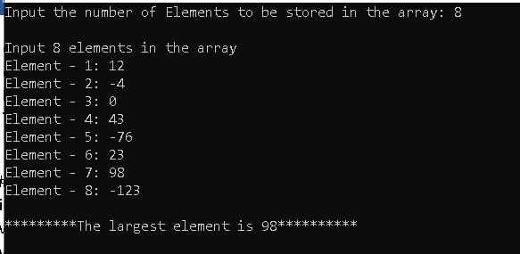

**HOME TASK 06**

**Write a program in C to find the square of any number using the function.**

**INPUT**

#include<stdio.h>

int square(int x);

void main()

{

int num,sqr;

puts("Enter a number to find its square:");

scanf("%d",&num);

sqr=square(num);

printf("The square of % d is %d",num,sqr);

getchar();

getchar();

getchar();

}

int square(int x)

{

return x*x;

}

**OUTPUT**

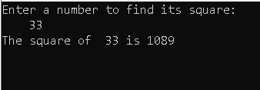

**HOME TASK 07**

**Print Calendar:**

**Modify the above program and add another function, printCalander(int month) the function should get only one argument i.e. month as integer and should print all the dates of that month with day names**.

**INPUT**

#include<stdio.h>

void printCalender(int month);

void printDay(void);

void printMonth(int month);

void main()

{

int month;

printf("Enter month Number : ");

scanf("%d",&month);

printMonth(month);

printDay();

printCalender(month);

getchar();

getchar();

getchar();

}

void printCalender(int month)

{

int i,n;

if(month==4||month==6||month==9||month==11)

n=30;

else if(month==2)

n=28;

else

n=31;

printf(" ");

for(i=0;i<31;i++)

{

printf("%d\t",i+1);

if(i%7==6)

printf("\n ");

}

}

void printDay(void)

{

puts(" Mon\tTue\tWed\tThu\tFri\tSat\tSun\n");

}

void printMonth(int month)

{

printf("\t\t********");

switch (month)

{

case 1:

puts("January********");

break;

case 2:

puts("Feburary********");

break;

case 3:

puts("March********");

break;

case 4:

puts("April********");

break;

case 5:

puts("May********");

break;

case 6:

puts("June********");

break;

case 7:

puts("July********");

break;

case 8:

puts("August********");

break;

case 9:

puts("September********");

break;

case 10:

puts("October********");

break;

case 11:

puts("November********");

break;

case 12:

puts("December********");

break;

}

puts("\n");

}

**OUTPUT**

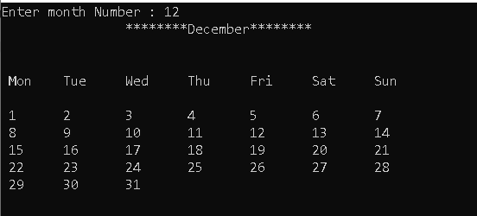

**HOME TASK 08**

**Write a program in C to swap two numbers using function.**

**INPUT**

#include<stdio.h>

int x,y;

void swap(int a,int b);

void main()

{

puts("Enter 1st number:");

scanf("%d",&x);

puts("Enter 2nd number :");

scanf("%d",&y);

printf("Before Swapping:\n\t n1=%d,\t n2=%d\n",x,y);

swap(x,y);

printf("After Swapping:\n \tn1=%d,\t n2=%d",x,y);

getchar();

getchar();

getchar();

}

void swap(int a,int b)

{

x=b;

y=a;

}

**OUTPUT**

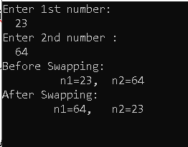

**THE END**